**SOFTWARE ENGINEERING**

**LAB – UML DIAGRAMS**

**COLLABRATION DIAGRAM:**

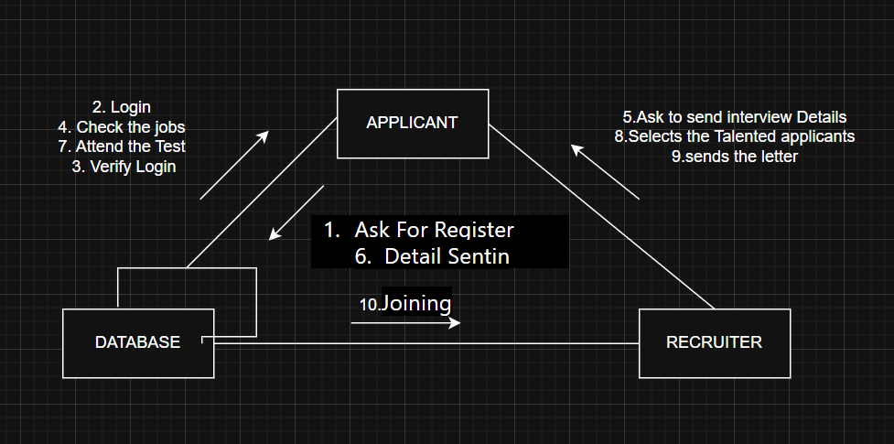

**DEPLOYMENT DIAGRAM:**

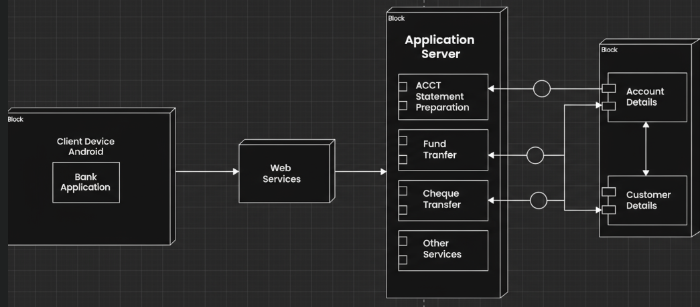

**COMPONENT DIAGRAM:**

